PROJECT REPORT

Traffic Crash Analytics & Safety Intelligence Platform

Submitted By: | KANISHKA THIYAGARAJAN
Technology Stack: | Python, MySQL, Pandas, Streamlit
Domain: | Transportation Analytics
Academic Year: | 2026

ABSTRACT
Road accidents remain one of the major causes of injuries, fatalities, and economic losses worldwide. The increasing availability of transportation data offers an opportunity to extract meaningful insights that can improve road safety and assist decision-makers.
The Traffic Crash Analytics & Safety Intelligence Platform is designed to analyze large-scale traffic crash data using advanced SQL techniques and present actionable insights through an interactive Streamlit dashboard. The project leverages a structured dataset containing crash details such as weather conditions, road types, injury severity, contributing causes, crash timings, and geographical information.
The system performs complex analytical operations including aggregations, Common Table Expressions (CTEs), ranking functions, and window functions to identify accident hotspots, peak crash periods, dangerous environmental conditions, and injury-prone locations. The insights generated can support traffic authorities, emergency response teams, insurance companies, urban planners, and policymakers in making informed decisions.

Contents
CHAPTER 1: INTRODUCTION 4
CHAPTER 2: PROBLEM STATEMENT 5
CHAPTER 3: OBJECTIVES 6
CHAPTER 4: SCOPE OF THE PROJECT 7
CHAPTER 5: SYSTEM DESIGN 8
CHAPTER 6: DATABASE DESIGN 9
CHAPTER 7: PROCEDURE 10
CHAPTER 8: TESTING 26
CHAPTER 9: ADVANTAGES 27
CHAPTER 10: LIMITATIONS 28
CHAPTER 11: FUTURE ENHANCEMENTS 29
CHAPTER 12: CONCLUSION 30

CHAPTER 1: INTRODUCTION
Transportation systems play a crucial role in economic development and societal well-being. However, traffic accidents continue to pose significant challenges, resulting in injuries, fatalities, and property damage.
Analyzing traffic crash data can help identify patterns and trends that contribute to accidents. Traditional reporting methods often fail to provide deep analytical insights from large datasets.
The Traffic Crash Analytics & Safety Intelligence Platform addresses this challenge by using SQL-based analytical techniques to process and analyze traffic crash records efficiently. The generated insights assist stakeholders in understanding risk factors and implementing preventive measures.

CHAPTER 2: PROBLEM STATEMENT
Traffic crash datasets contain valuable information regarding accident patterns, environmental conditions, contributing factors, and injury severity.
However:
- Large volumes of crash records make manual analysis difficult.
- Identifying trends and risk factors requires advanced analytical techniques.
- Decision-makers need meaningful insights rather than raw data.
- Existing systems often lack interactive analytical capabilities.

Therefore, a comprehensive analytical platform is required to transform raw traffic crash data into actionable intelligence.

CHAPTER 3: OBJECTIVES
Primary Objective
To develop an analytical platform that extracts meaningful insights from traffic crash data using advanced SQL techniques and presents results through an interactive dashboard.
Specific Objectives
- Load crash data into a relational database.
- Perform exploratory data analysis.
- Implement advanced SQL queries.
- Identify accident hotspots.
- Analyze injury patterns.
- Discover high-risk environmental conditions.
- Evaluate crash trends over time.
- Present results through Streamlit.
- Generate business insights.

CHAPTER 4: SCOPE OF THE PROJECT
The project focuses on:
Included
- Traffic crash analysis
- SQL-based analytics
- Dashboard visualization
- Injury analysis
- Crash hotspot detection
- Time-based trend analysis
Excluded
- Real-time data processing
- Predictive machine learning models
- GIS integration
- External API integration

CHAPTER 5: SYSTEM DESIGN
Architecture Diagram

Chicago Traffic Crash Dataset
│
▼
SQLite Database
│
▼
SQL Analysis
│
▼
Python Integration
│
▼
Streamlit Dashboard
│
▼
Business Insights

CHAPTER 6: DATABASE DESIGN
Database : MySQL
Table : Traffic_Crashes
Key Attributes
Attribute | Description
CRASH_RECORD_ID | Unique Crash ID
CRASH_DATE | Crash Date
WEATHER_CONDITION | Weather Type
LIGHTING_CONDITION | Lighting Status
FIRST_CRASH_TYPE | Crash Type
TRAFFICWAY_TYPE | Road Type
PRIM_CONTRIBUTORY_CAUSE | Primary Cause
INJURIES_TOTAL | Total Injuries
CRASH_HOUR | Crash Hour
STREET_NAME | Street Name
LATITUDE | Latitude
LONGITUDE | Longitude
YEAR | Crash Year

CHAPTER 7: PROCEDURE

Phase 1: Data Loading
Steps
- Read CSV file.
- Create MySQL database named CRASH
- Load records into Traffic_Crashes table.
- Verify schema and row count.

Phase 2: Data Exploration
Techniques
- COUNT
- GROUP BY
- ORDER BY
- DISTINCT
- Aggregate Functions
Purpose:
- Understand crash distribution.
- Identify common causes.
- Explore time trends.

Phase 3: Advanced SQL Analytics
Query 1 - Top 5 dangerous combinations of weather and crash type.
This analysis identifies the combinations of weather conditions and crash types that result in the highest number of accidents. Understanding these combinations helps traffic authorities implement targeted safety measures during adverse weather conditions.
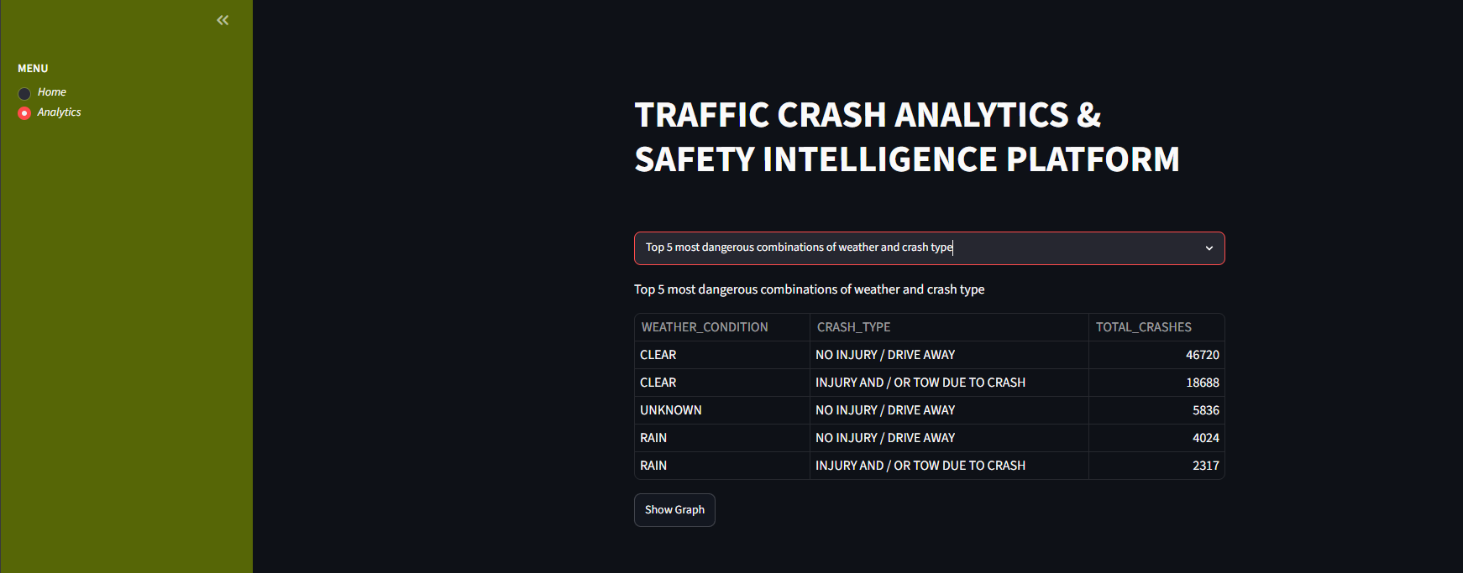
Recommended Visualization: Horizontal Bar Chart (Best Choice)

SQL Concepts Used: GROUP BY, COUNT() , ORDER BY ,LIMIT 5
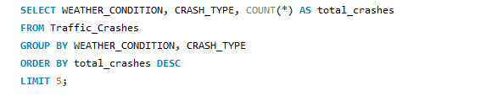

Query 2 - Top 10 streets with highest injury crashes.
This analysis identifies the streets that have recorded the highest number of crashes resulting in injuries. By focusing on injury-related accidents rather than total crashes, the analysis highlight’s locations that pose the greatest risk to public safety.
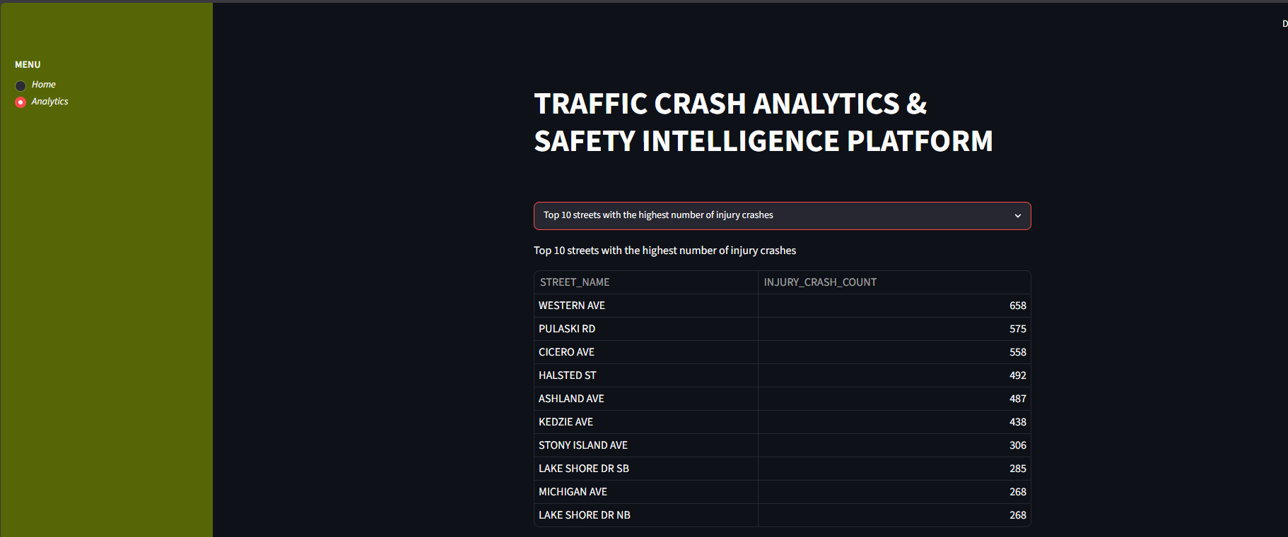
Recommended Visualization: Bar Chart
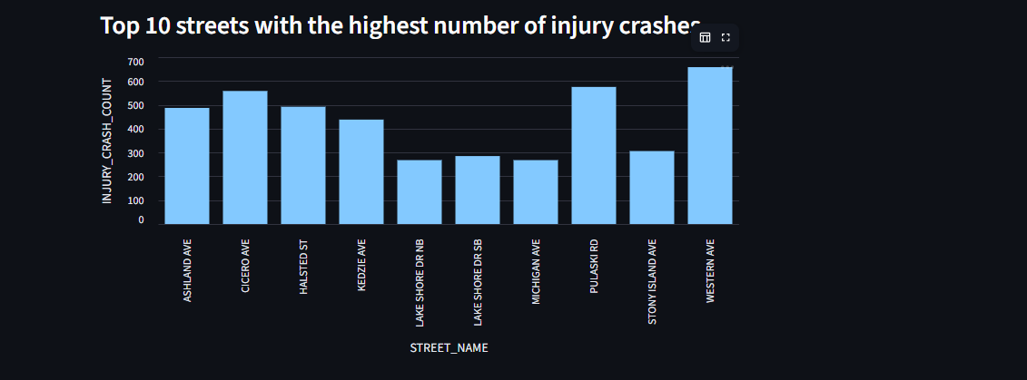
SQL Concepts Used: WHERE INJURIES_TOTAL > 0 , GROUP BY, COUNT(), ORDER BY , LIMIT 10
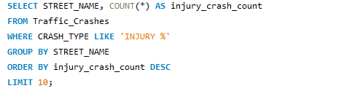

Query 3 - Percentage of injury crashes for each crash type.
This analysis calculates the percentage of crashes that resulted in injuries for each crash type. It helps identify which types of collisions are more likely to cause injuries, allowing authorities to focus on preventing high-severity accidents.
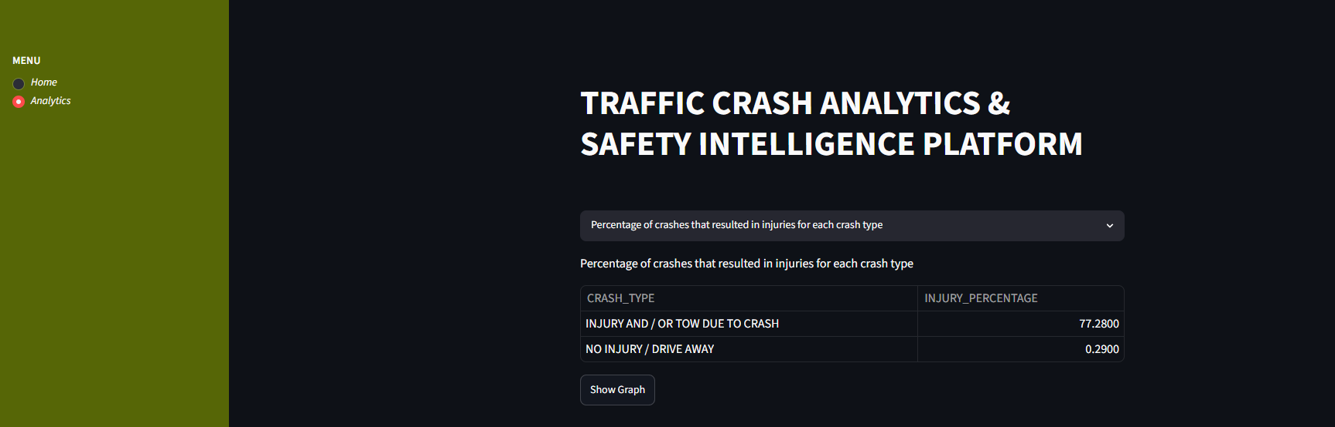
Recommended Visualization: Pie Chart
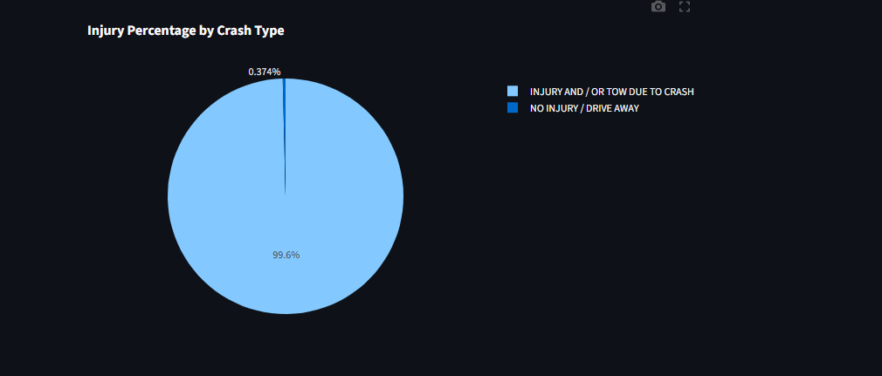

SQL Concepts Used: COUNT(), SUM(), Percentage Calculation, ROUND(), GROUP BY, ORDER BY
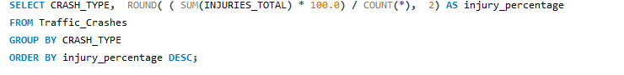

Query 4 - Peak crash hour for each month.
This analysis identifies the hour of the day with the highest number of crashes for each month. Understanding peak crash hours helps stakeholders recognize periods of increased accident risk and implement appropriate safety measures.
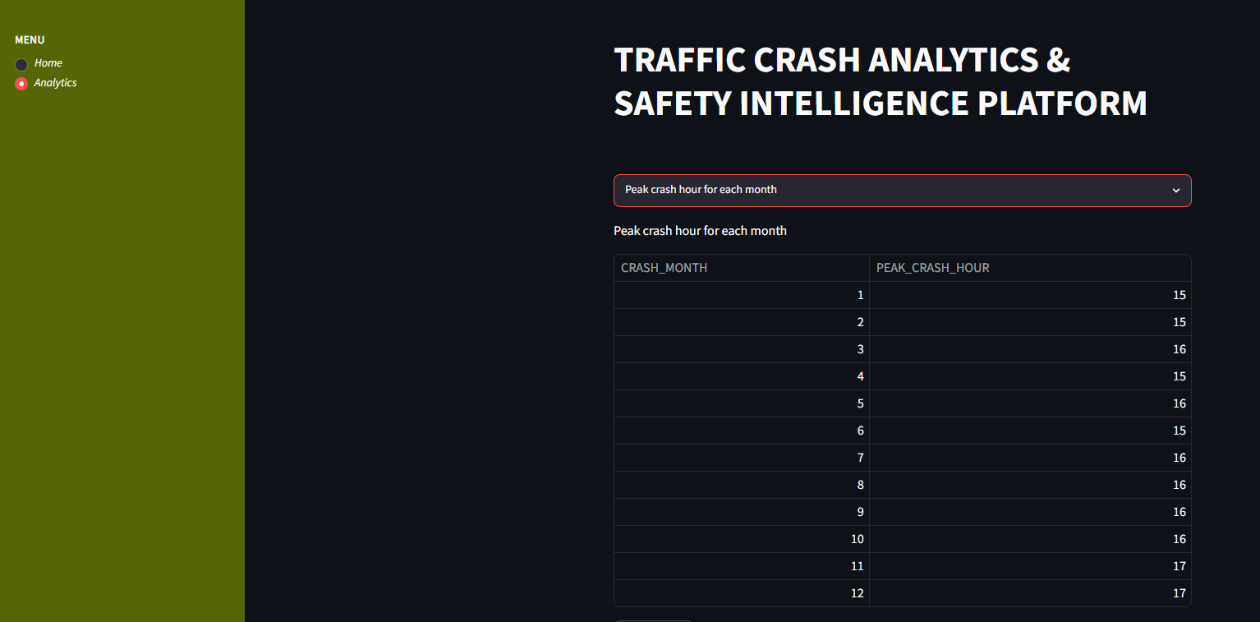
Recommended Visualization: Scatter Plot
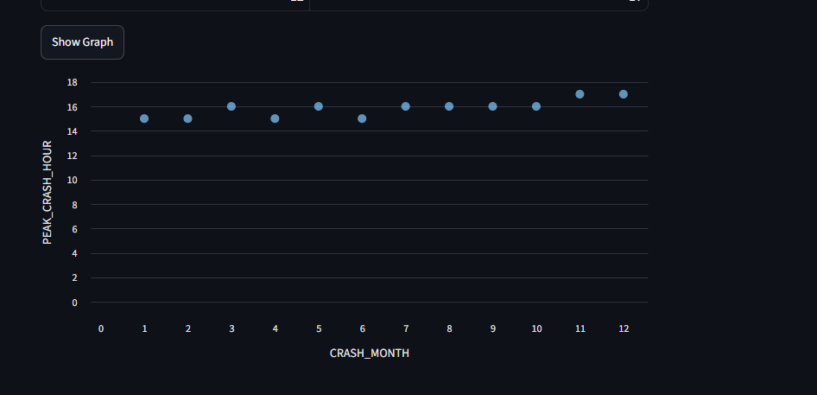
SQL Concepts Used: GROUP BY,COUNT(), RANK(), ORDER BY
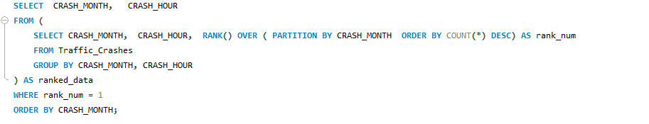
Query 5 - Top 5 primary causes during night time.
This analysis identifies the five most common primary causes of traffic crashes that occur during nighttime hours (typically between 6:00 PM and 11:59 PM). Understanding these causes helps stakeholders develop targeted strategies to reduce accidents during periods of reduced visibility and increased driving risk.
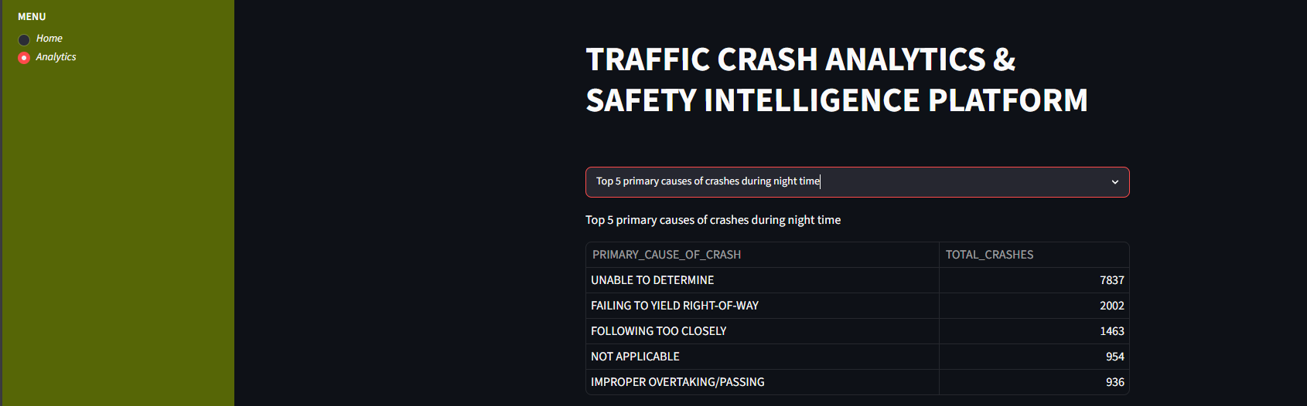
Recommended Visualization: Line Chart
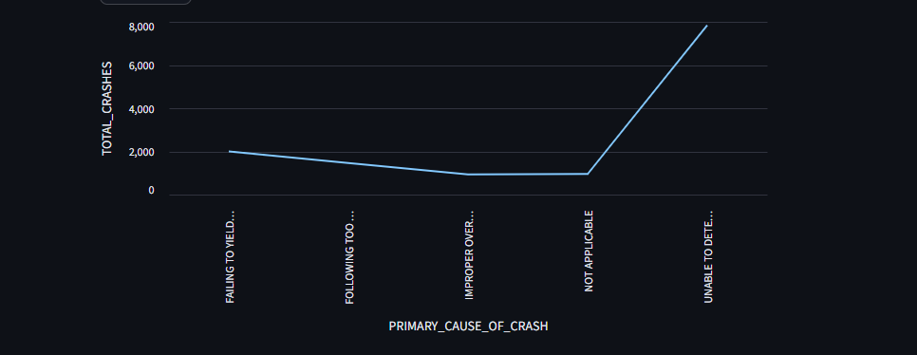
SQL Concepts Used: WHERE CRASH_HOUR >= 18, GROUP BY, COUNT(), ORDER BY, LIMIT 5
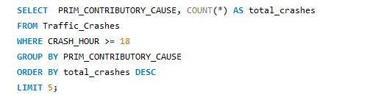

Query 6 - Average injuries in daylight versus darkness.
This analysis compares the average number of injuries per crash under different lighting conditions, specifically Daylight and Darkness. The goal is to understand how visibility affects the severity of traffic accidents and identify conditions associated with higher injury rates.
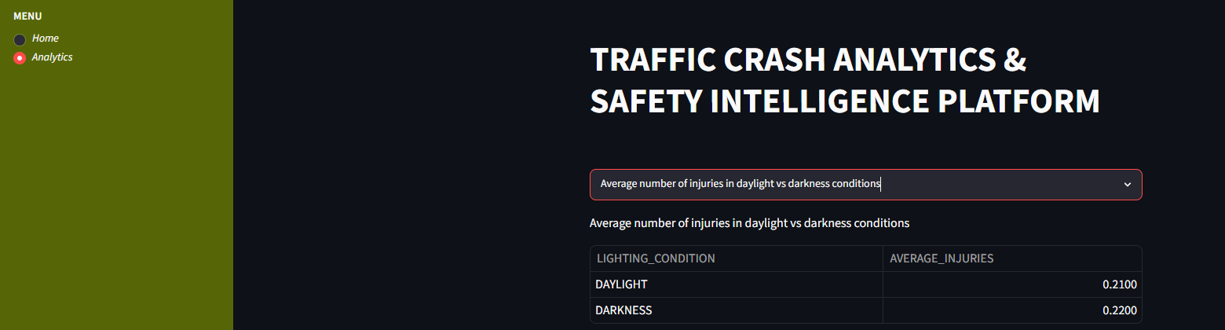
Recommended Visualization: Bar Chart
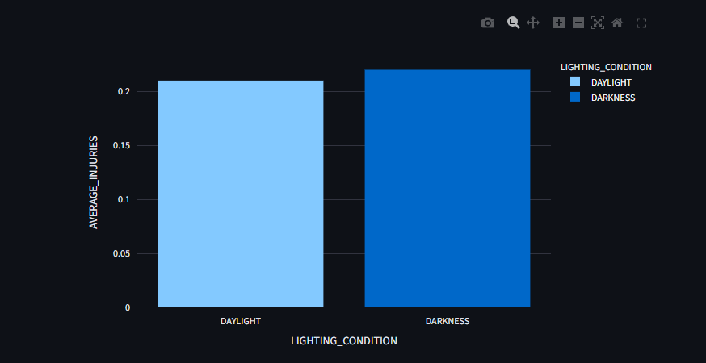

SQL Concepts Used: WHERE, AVG(INJURIES_TOTAL), ROUND(), GROUP BY
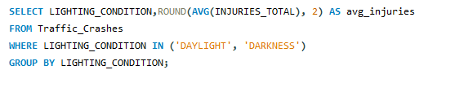

Query 7 - Traffic control device with highest injuries.
This analysis identifies the traffic control device type associated with the highest average number of injuries per crash. Traffic control devices such as traffic signals, stop signs, yield signs, and warning signs are designed to regulate traffic flow and enhance road safety. Understanding which device type is linked to more severe crashes can help authorities improve traffic management strategies.
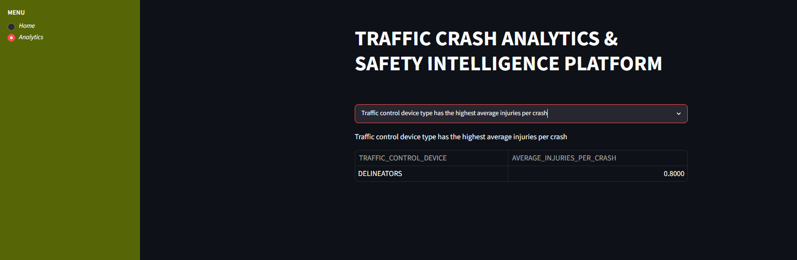

SQL Concepts Used: GROUP BY, AVG(INJURIES_TOTAL), ROUND(), ORDER BY DESC, LIMIT 1
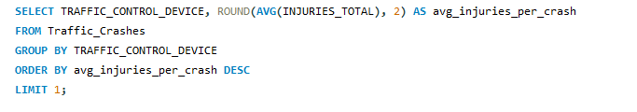

Query 8 - Top 5 crash locations by frequency.
This analysis identifies the five geographic locations (based on latitude and longitude coordinates) with the highest number of recorded crashes. These locations represent accident hotspots where crashes occur more frequently than in other areas.
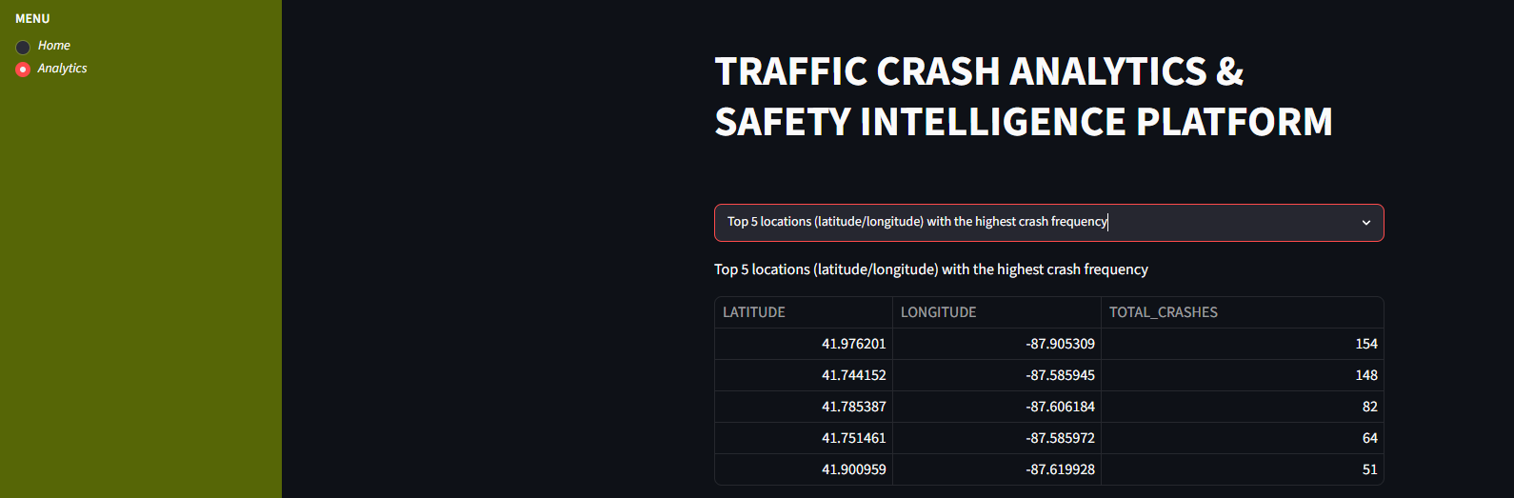

Recommended Visualization: Scatter Plot (Latitude vs Longitude)
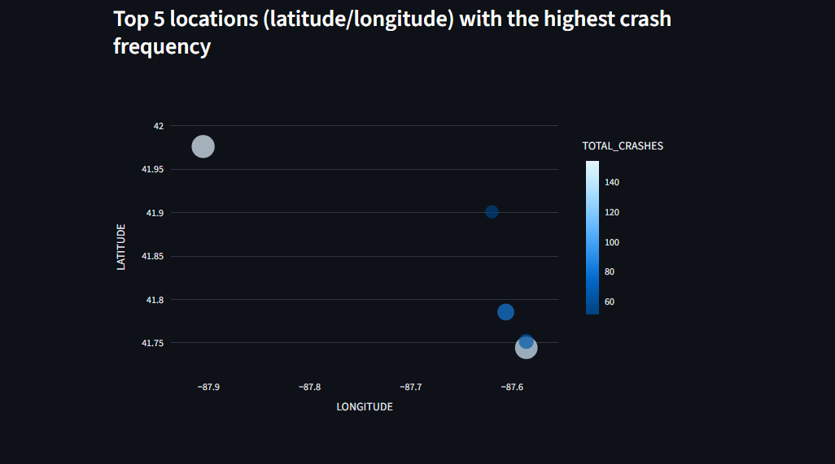

SQL Concepts Used: GROUP BY, COUNT(), ORDER BY DESC, LIMIT 5
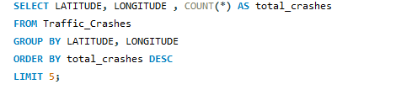
Query 9 - Top streets with highest injury rates.
This analysis identifies the streets with the highest injury rates, considering only streets that have recorded more than 100 crashes. Instead of focusing solely on the number of crashes, it measures the proportion of crashes that resulted in injuries, providing a better understanding of road safety risks.
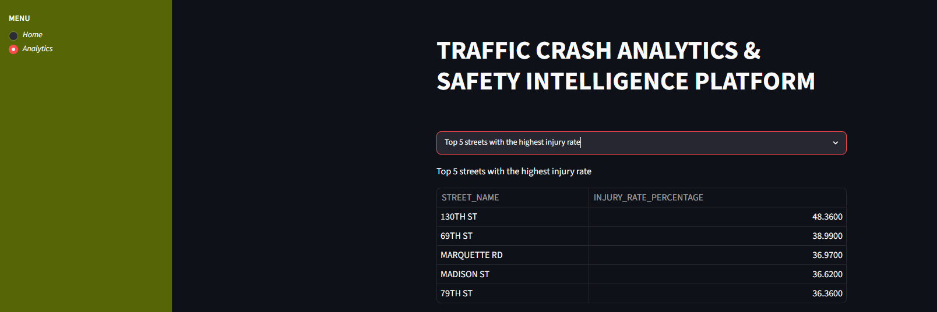
Recommended Visualization: Scatter Plot
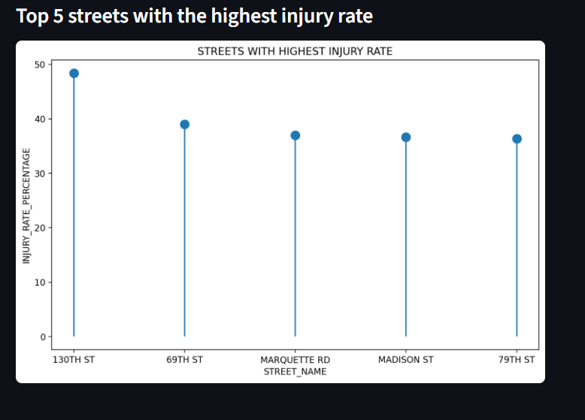
SQL Concepts Used: GROUP BY, COUNT(), SUM(),Percentage Calculation, HAVING COUNT(*) > 100, ORDER BY, LIMIT 5
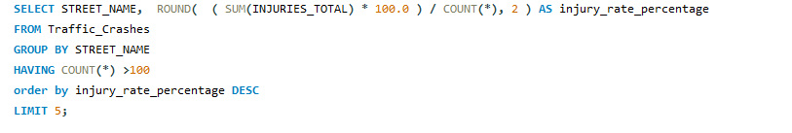

Query 10 - Most common crash type per year.
This analysis identifies the most frequently occurring crash type for each year in the dataset. By examining yearly crash patterns, stakeholders can understand how accident trends evolve over time and determine whether specific crash types consistently dominate road incidents.
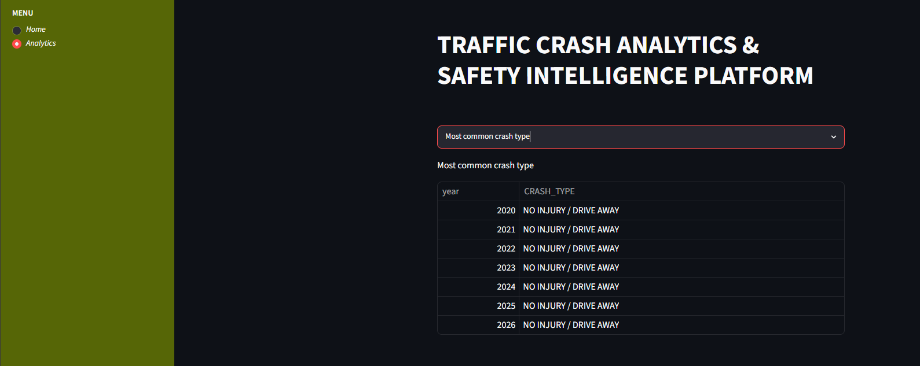

SQL Concepts Used: GROUP BY, COUNT(), RANK(), PARTITION BY YEAR, ORDER BY

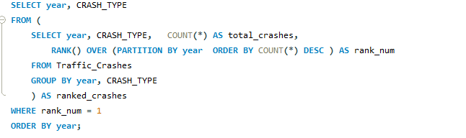

Query 11 - Day of week with highest average crashes.
This analysis identifies which day of the week experiences the highest average number of crashes per hour. Rather than simply counting total crashes, it measures crash frequency relative to time, providing a more accurate view of daily accident risk.
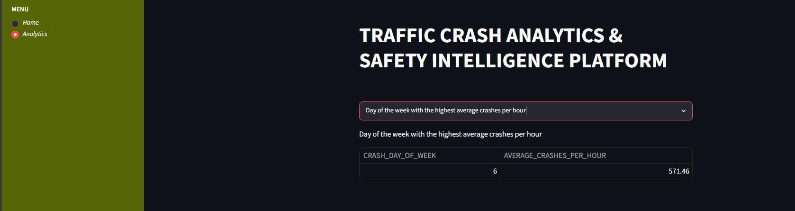

SQL Concepts Used: GROUP BY,COUNT(), ORDER BY, LIMIT 1

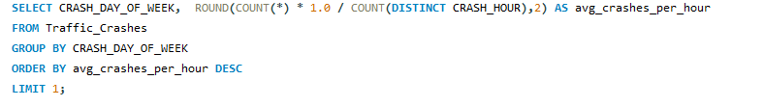

Query 12 - High-risk time bucket analysis.
This analysis groups crash hours into broader time buckets—Morning, Afternoon, Evening, and Night—and identifies which period experiences the highest number of injury-related crashes. Grouping hours into buckets simplifies the analysis and helps stakeholders understand when accidents are most severe.
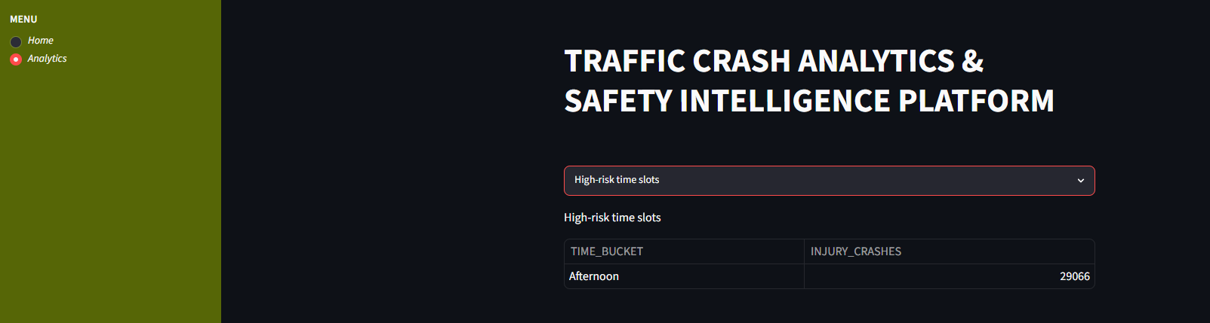

SQL Concepts Used: CASE WHEN, GROUP BY, SUM(INJURIES_TOTAL), COUNT(), ORDER BY
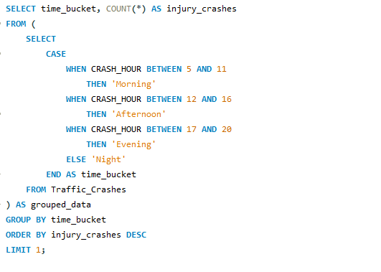

Query 13 - Top 3 causes per crash type.
This analysis identifies the three most common contributing causes associated with each crash type. By examining the relationship between crash types and their primary causes, stakeholders can better understand the factors leading to specific kinds of accidents and develop targeted prevention strategies.
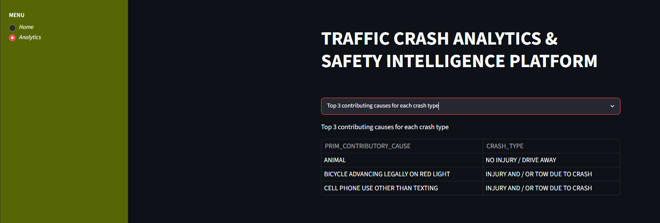

SQL Concepts Used: GROUP BY, COUNT(), RANK(), PARTITION BY FIRST_CRASH_TYPE, LIMIT 3
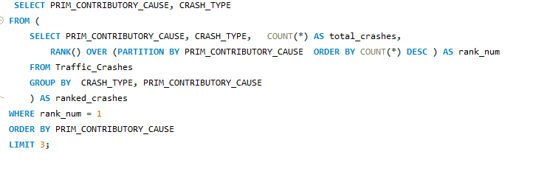

Query 14 - Year-over-year crash growth.
This analysis measures the percentage increase or decreases in the total number of crashes from one year to the next. It helps identify long-term trends in traffic accidents and evaluate whether road safety initiatives are improving or worsening over time.
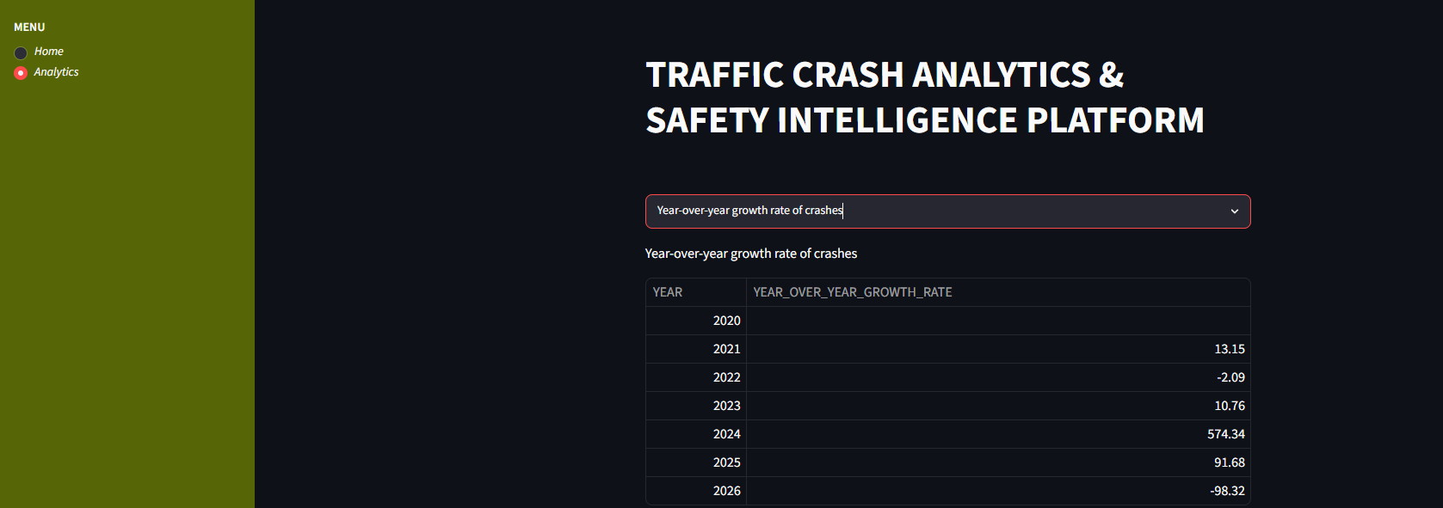

Recommended Visualization: Line Chart 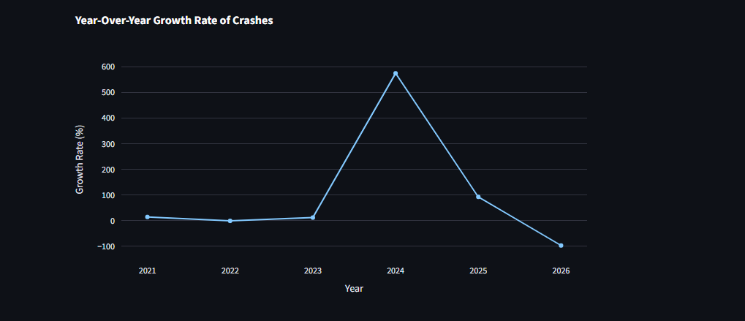
SQL Concepts Used: COUNT(), GROUP BY, LAG() Window Function, ROUND()
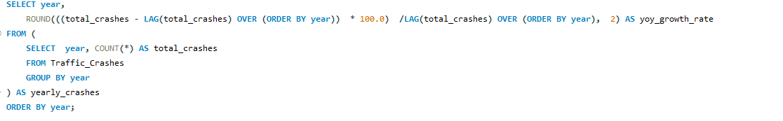
Query 15 - Hotspot zone identification.
This analysis identifies geographic hotspot zones where traffic crashes occur most frequently. Nearby crash locations are grouped by rounding their latitude and longitude values to two decimal places, allowing the detection of areas with high accident concentrations rather than individual crash points.
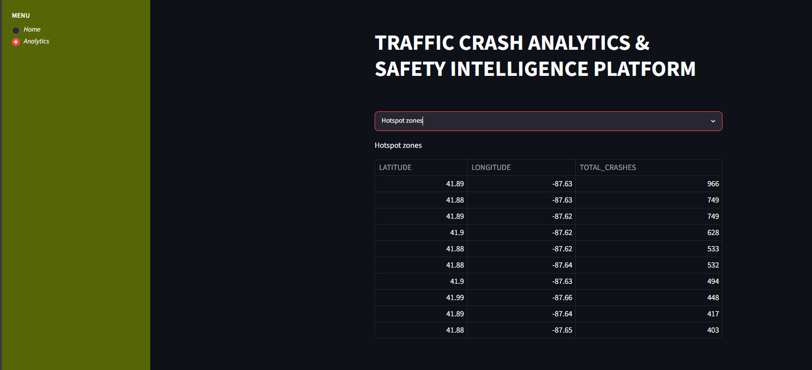
Recommended Visualization: Scatter Plot
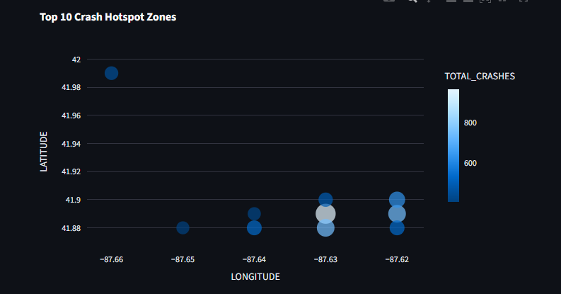
SQL Concepts Used: ROUND(), GROUP BY, COUNT(), ORDER BY DESC, LIMIT 10
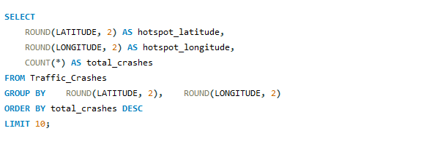

CHAPTER 8: TESTING
Functional Testing

Test Case | Expected Result
Data Loading | Records inserted
Database Connection | Successful
Query Execution | Correct output
Dashboard Rendering | Table displayed
User Selection | Correct filter

Performance Testing

Parameter | Result
Data Volume | 84K+ Records
Query Execution | Successful
Dashboard Response | Acceptable

CHAPTER 9: ADVANTAGES

- Fast Analysis of Large Datasets: Efficiently processes and analyzes thousands of crash records using SQL queries, reducing manual effort and saving time.
- Accurate SQL-Based Insights: Generates reliable, data-driven insights through advanced SQL techniques such as aggregations, CTEs, and window functions.
- Interactive Dashboard: Provides a user-friendly Streamlit interface for exploring crash data and viewing analytical results.
- Supports Decision-Making: Helps traffic authorities, insurance companies, and policymakers make informed decisions based on accident trends and risk factors.
- Scalable Architecture: The modular design allows easy expansion to larger datasets, additional features, and more powerful database systems.
- Real-World Business Applicability: Addresses practical transportation and road safety challenges, making it valuable for industry and government use.

CHAPTER 10: LIMITATIONS

- No Predictive Analytics: The system focuses on analyzing historical crash data and identifying patterns but does not predict future accidents or crash probabilities using machine learning models.
- Historical Data Only: Insights are generated from previously recorded crash events, which may not fully reflect current traffic conditions, infrastructure changes, or recent safety measures.
- No Real-Time Monitoring: The platform does not support live data streaming or real-time accident tracking, limiting its ability to provide immediate alerts and dynamic updates.
- Limited Geographical Coverage: The analysis is based on the Chicago Traffic Crashes dataset, making the findings specific to that region and not directly applicable to other cities or countries without additional datasets.

CHAPTER 11: FUTURE ENHANCEMENTS
Machine Learning
- Accident prediction models.
- Severity prediction.
GIS Integration
- Interactive maps.
- Spatial analysis.
Real-Time Analytics
- Live crash monitoring.
- Alert systems.
Advanced Visualization
- Heatmaps.
- Geospatial dashboards.

CHAPTER 12: CONCLUSION
The Traffic Crash Analytics & Safety Intelligence Platform successfully converts large volumes of traffic crash data into meaningful and actionable insights through advanced SQL analytics and an interactive Streamlit dashboard. By analyzing crash patterns, injury trends, environmental conditions, and accident-prone locations, the system helps identify key factors contributing to road accidents.
The project demonstrates practical application of SQL, database management, Python programming, data analysis, and dashboard development to solve real-world transportation challenges. The generated insights can support traffic authorities, urban planners, emergency services, and policymakers in improving road safety and making data-driven decisions. Overall, the platform serves as an effective analytical tool for understanding traffic crash behavior and promoting safer transportation systems.

